**Project Design Phase**

**Problem – Solution Fit Template**

|  |  |
| --- | --- |
| Date | 27 June 2025 |
| Team ID | LTVIP2025TMID30306 |
| Project Name | EduTutor AI: Personalized Learning with Generative AI and LMS Integration |
| Maximum Marks | 2 Marks |

**Problem – Solution Fit Template:**

The Problem–Solution Fit demonstrates that you've clearly identified a core issue faced by your target users and designed a solution that addresses it meaningfully. This process bridges user needs with product design to ensure stronger adoption and real-world impact.

**Purpose:**

* Address the learning gaps of students through adaptive, AI-driven tutoring support.
* Accelerate learning outcomes by tailoring content to individual learner needs and pace.
* Integrate with existing Learning Management Systems (LMS) to streamline the educational experience.
* Leverage AI to provide 24/7 mentorship, personalized feedback, and content recommendations.
* Align product communication with student behaviours, ensuring higher engagement and satisfaction.

**Template:**

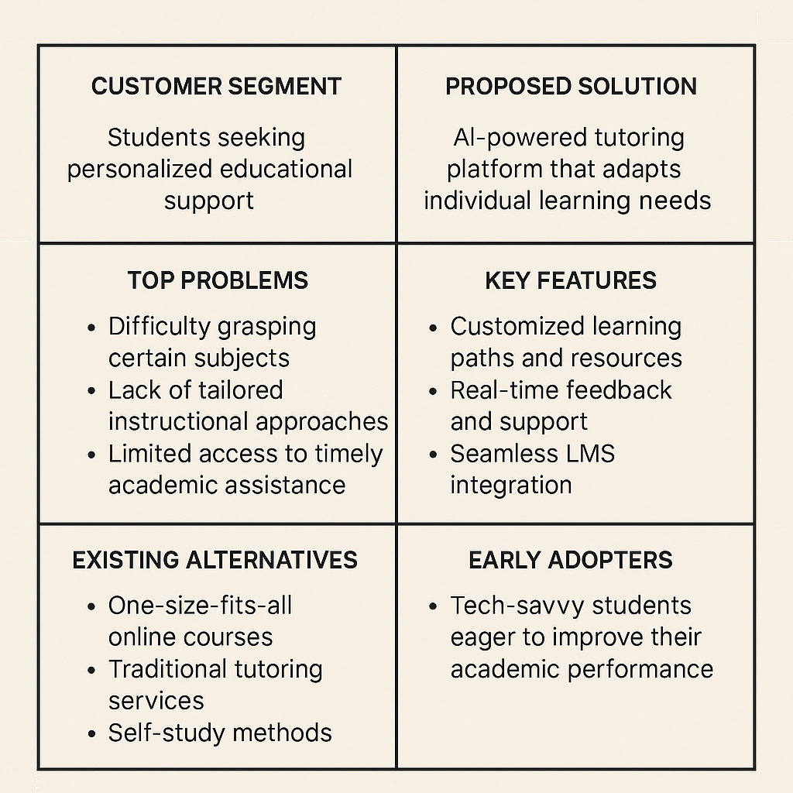

References:

1. <https://www.ideahackers.network/problem-solution-fit-canvas/>
2. <https://medium.com/@epicantus/problem-solution-fit-canvas-aa3dd59cb4fe>